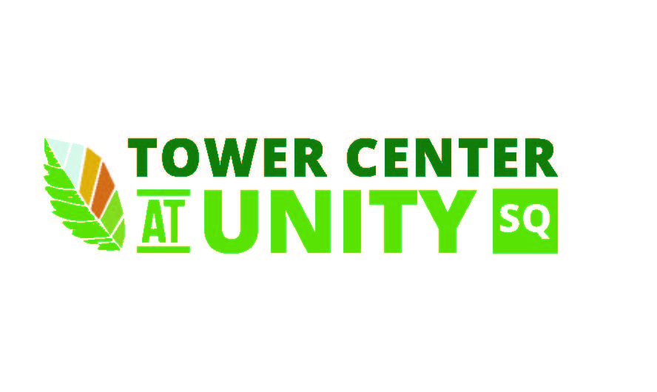

Any area at Unity Square may be reserved. When an area is not reserved, use of the area is free and fully available to the public

Private Individual Rental Rates & Procedure
- There are four areas available:
- The Green, The Center Stage, The Fountain, and The Flowers.
- They are $25 per hour / per area for a minimum of two hours.
- Talk to us about special times and prices for FREE community events. Clean up, electric hookup and deposit fees may apply.

Festival/Fundraiser Organizer Rental Rates & Procedure
- The entire Unity Square may be reserved:
- Half day (6 hours) for $500 / Full day (up to 12 hours) for $800
- Multi day rentals receive 20% off listed price.
- Reservations are made on a first come, first served basis in person or by phone at 918.337.2787.
- Payment, liability insurance and signed contract must be received before the reservation can be finalized.
- Payments may be made at The Center from 8:30 a.m. - 5 p.m., Monday - Friday, or after hours by appointment.

Labor, Technical & Equipment Rates
- Labor: Cost will be based on event setup needed.
- Security Officer: $50 per officer, per hour – required for events with alcohol service.
- Equipment: Ettinger’s Office Supply has event equipment for rent (chairs, tables, catering supplies etc.) 918.633.1911.
- Technical: When Unity Square technical equipment (sound, lighting, video, etc.) is used, BCC technical department heads must be hired to operate said equipment. The first department head will be billed at the rate of $60 per hour and the others (if needed) will be billed at the rate of $30 per hour. All positions require a 4-hour minimum. Any additional BCC technical support (stagehands) will be billed at $30 per person, per hour, with a 4-hour minimum per person.
  - Stage Shade: $100
  - Projector & Screen: $1300
  - Sound System: Included in rental cost. Technical labor is calculated as outlined above.
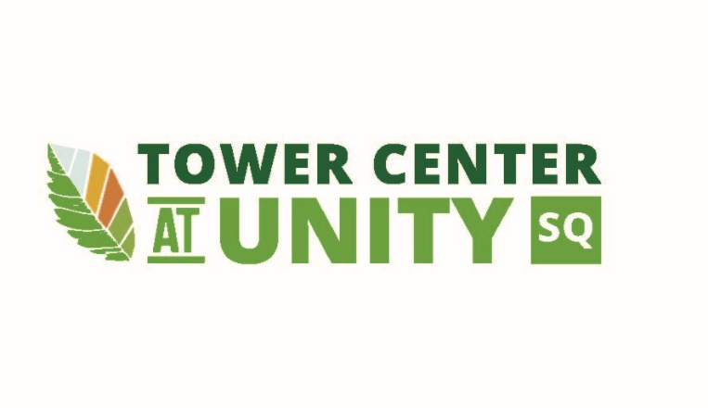
  - Concert Sound System: $300. Technical labor is calculated as outlined above.
2025-2026

